Homework #8: CBAM - Convolutional Block Attention Module
Deep Learning for Computer Vision (EN.525.733) | Summary of Woo et al., ECCV 2018
Paper purpose
Woo, Park, Lee, and Kweon propose CBAM, a lightweight attention module that can be inserted into standard convolutional neural networks to improve feature representation without redesigning the whole architecture. Instead of only increasing network depth, width, or cardinality, CBAM improves a CNN by learning which features should be emphasized and which should be suppressed. The module is end-to-end trainable and is designed as a plug-and-play block that adds very little parameter or computation overhead.
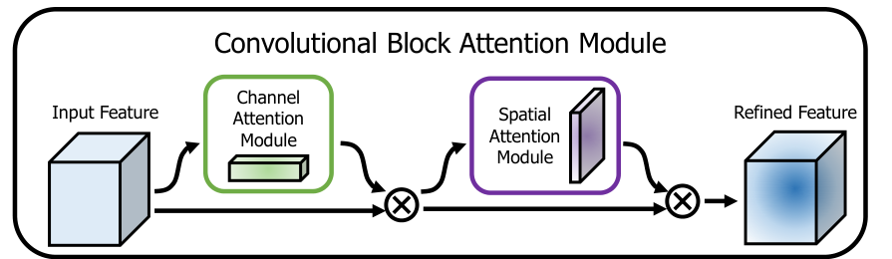
Figure 1. CBAM overview from the paper: channel attention followed by spatial attention.
Architecture summary
CBAM operates on an intermediate feature map F with shape C x H x W. It refines F in two sequential stages. First, the channel attention module produces a C x 1 x 1 attention vector and multiplies it with F, asking what channels are most meaningful. Second, the spatial attention module produces a 1 x H x W attention map and multiplies it with the channel-refined feature map, asking where the informative image regions are. The output has the same shape as the input feature map, so it can be inserted directly inside existing CNN blocks.
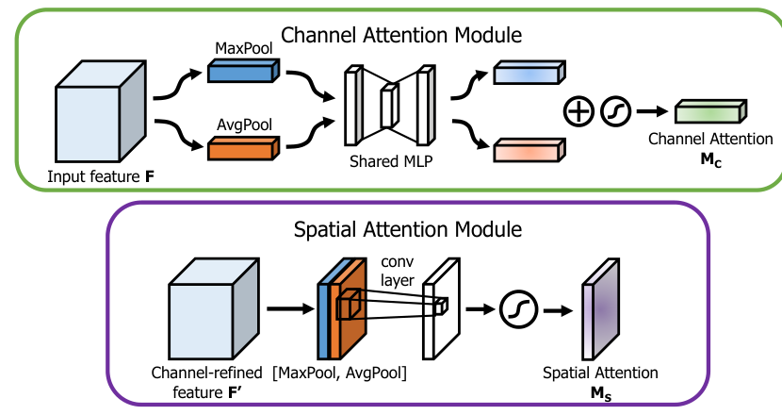
Figure 2. Channel and spatial attention sub-modules reproduced from the assigned paper.
How the two attention modules work
Channel attention: “what” to emphasize | Spatial attention: “where” to emphasize
Uses global average pooling and max pooling over spatial dimensions. The two descriptors pass through a shared MLP, are summed, then normalized by sigmoid. Using both pooling types was better than average pooling alone, which is the main channel-only idea used in SE networks. | Uses average pooling and max pooling across the channel dimension, concatenates the two 2D maps, then applies a 7 x 7 convolution followed by sigmoid. The larger 7 x 7 kernel performed best because spatial attention benefits from a wider receptive field.
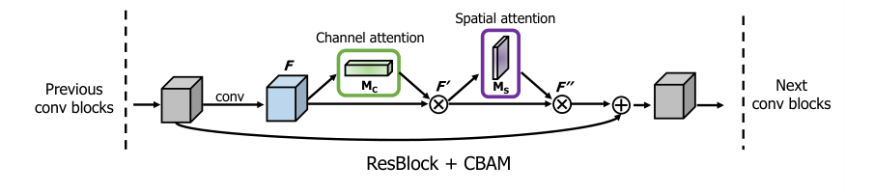
Figure 3. CBAM inserted into a ResNet residual block, as shown in the paper.
Authors findings
• Ablation results: The authors found that the final design works best when average pooling and max pooling are both used, channel attention is followed by spatial attention, and the spatial branch uses a 7 x 7 convolution. Sequential channel-first attention outperformed spatial-first and parallel arrangements.
• Image classification: Across ImageNet-1K experiments, CBAM consistently improved ResNet, WideResNet, ResNeXt, and MobileNet baselines. For example, ResNet-50 top-1 error dropped from 24.56% to 22.66%, while ResNet-50 + SE reached 23.14%. This shows that CBAM improved on a strong channel-only attention method.
• Object detection: The gains also transferred beyond classification. On MS COCO with Faster R-CNN, adding CBAM improved mAP@[.5,.95] for both ResNet-50 and ResNet-101 backbones. On VOC 2007 with StairNet, CBAM improved mAP with both VGG16 and MobileNet backbones while adding negligible parameters.
• Visualization: Grad-CAM examples showed that CBAM-enhanced networks focused more tightly on target objects and produced higher confidence for ground-truth classes. The authors argue that the performance gain comes from better attention to useful object regions and reduced influence from background clutter.
Conclusion
Overall, CBAM is important because it provides a simple architectural improvement for CNNs: it adds attention along both channel and spatial dimensions while preserving the original network structure. Its main contribution is not a new backbone, but a compact refinement block that can make many CNN architectures more accurate with small computational cost. The paper demonstrates this through ablation studies, ImageNet classification, MS COCO detection, VOC detection, and Grad-CAM visualization.
Reference: Woo, S., Park, J., Lee, J.-Y., & Kweon, I. S. (2018). CBAM: Convolutional Block Attention Module. ECCV 2018.

